Next, select a Class A, B, and C IP (v4) address for input into the subnet calculator.
- Class A: 1.0.0.1 - 126.255.255.254
- Class B: 128.1.0.1 - 191.255.255.254 …..
- Class C: 192.0.1.1 - 223.255.254.254
If you want to increase the number of subnets, you simply change the Maximum Subnets field input to your desired number. When you increase this number, what happens to the Host per Subnet field and why?
compare the characteristics of IPv4 and IPv6. Discuss any benefits one provides over the other.
IPv4(Internet Protocol ver. 4): It is 32-bit integer address represented by 4 numbers (binary digits usually) in the range of 0-255 separated by a dot. “.”
IPv6(Internet Protocol ver. 6): updated version of Ipv4 with better efficiency and complexity. It is a 128-bit integer address represented by a group of 8 hexadecimal numbers separated by a colon. “:”
IPv6 has more benefits than IPv4 as it is newer than IPv4 and it has more features. In addition, for the USA, the government It has a larger address space to expand the IP connected Devices shown with the 128-bit IP address than the 32-bit address from IPv4. The security is also updated and improved than the IPv4 version such as Data security (authentication/encryption) and so the internet connection will be secure. It also has a similar header structure which increases the speed of the internet connection than IPv4. It also prioritizes better quality on websites. It also supports mobile devices better. It also does not need any class specifications like IPv4 like Class A, B, C, etc. IPv6 is mostly used in countries well developed such as the USA, while IPv4 is still used in other countries. The reason why some might prefer IPv6 is because of its 128-bit address format with 3.4E38 of unique IP address.
The differences between the two is that IPv4 is a 32-bit while IPv6 is a 128-bit. IPv4 header length is 20 to 60 bytes, while IPv6 is 40 bytes. Ipv4 has a manual or DHCP, while IPv6 is auto configuration. IPv4 does not offer security unlike IPv6 with IPsec support.
When you increase the maximum subnets field, the hosts per subnet is calculated by the equation 2^h-2 where h is the number of host bits. Using the powers of 2s chart can help find the correct calculations to the host per subnet field. As the maximum subnet increases, it changes the about of subnet bits, mask bits, which is then calculated into the hosts per subnet bits. The subnet and mask bits are increased due to the number of bits used for the IP address of the network which is subnetting. When calculated into the hosts per subnet bits, the subnet field decreases as there are more bits when subnetting, leaving fewer bits for the hosts. The subtractions are taking off the network address and the broadcast address which is not assigned to hosts. As the subnets increase, the mask bits increase by another bit/bits to the subnet part which is half of the available host address.
Class A: 119.225.225.1
2^h-2 = 2^sol
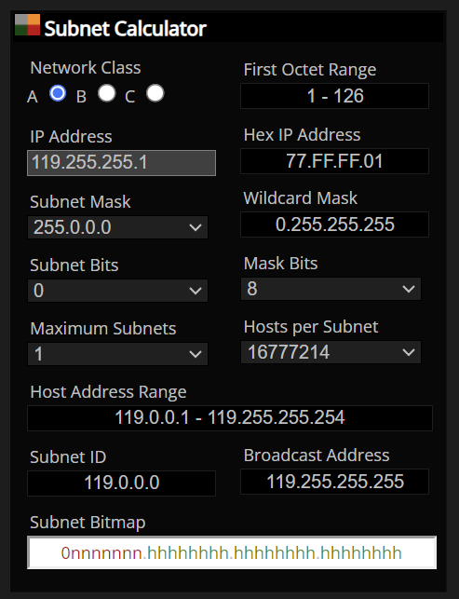
Class B: 160.255.255.1
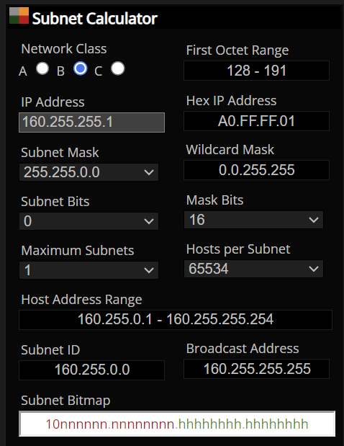
Class C: 199.255.254.1


